2023 ST JOSEPH’S SCHOOL LEADERS
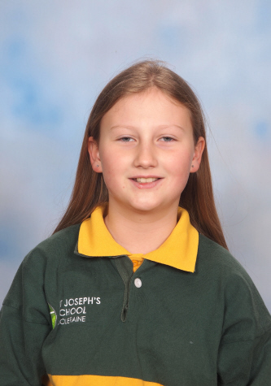  Lacey Dickson  Student Council Leader  Mini Vinnies President | 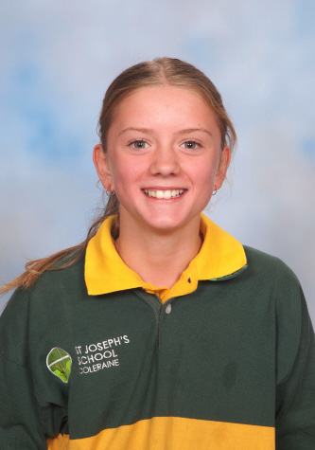  Hannah Lambert  Mini Vinnies Mission Leader  MacKillop House Captain | Maddison Munro  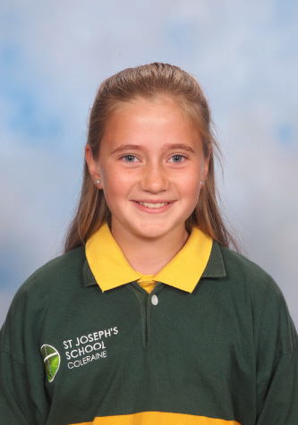  Wellbeing Leader  Mercy House Captain

2023 ST JOSEPH’S SCHOOL LEADERS
Liam Paton  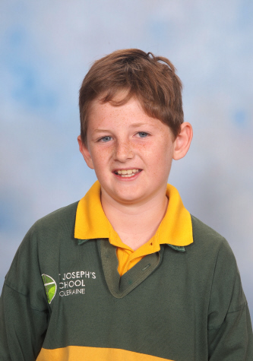  Arts Leader  McAuley House Captain | Angus Tindall  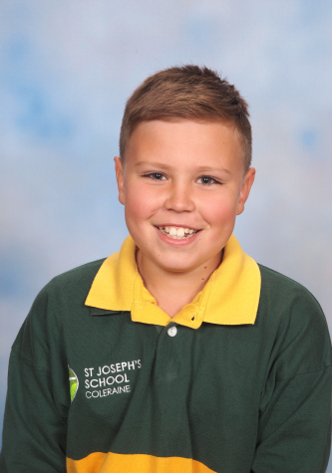  Environment and Sustainability Leader

