MANY PARTS, ONE BODY
St Paul’s First Letter to the Corinthians (Cor 12)

Draw or paste a picture of yourself in the middle piece.
Draw or paste pictures of people you love around you.
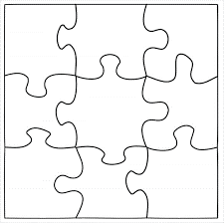

ME

We may feel a bit broken apart now, but we still we still make up one body as a community of faith in Spirit.

